BTEC Certificate Enterprise Transition work 2020
As part of the one-year Enterprise course you will be studying from September you will need to develop an understanding of how businesses manage their finances and make a profit. The first part of your transition work is to research the following key business terms, find a definition and consider how they affect businesses.
Key Business Term | Explanation | How this affects business
Profit

Break even

Costs

Revenue

Debt

For another part of the course you will be writing a plan to start our own small business. Your second transition task I would like you to think of three business idea. What businesses do you think will be successful in the Wirksworth and why?
Business Idea | Why this would be successful

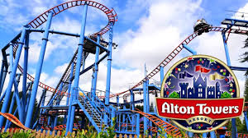
For the final part your transition work I want you to focus on Alton Towers. I want you to look at one of their recent major attractions, for example The Wickerman. Once you have selected a ride, answer the following questions:
Why do Alton Towers keep having to create new rides?

Research how much it cost Alton Towers to create one of its new rides?

Research the name of the new ride that is being launched this summer. How long did this take to create and why is this different to the Wickerman ride?

