# Anthony Gell School

**Mathematics Department**



# Bridging the gap between GCSE and A Level Mathematics

**Why are you receiving this booklet?**

A level Mathematics is a rewarding, exciting and absorbing subject that will allow you to choose a variety of career paths. However, it is a demanding and challenging subject. To support the transition from GCSE to A level it is vitally important that you are confident and flexible with your current set of mathematical skills. This booklet focuses on the foundations of A level Mathematics that will be used throughout the course. As a result of this, it is important that you work through the three sections, carefully following the examples(please note that in most cases the solutions shown are only one way of working as alternative approaches are often used) and then attempting the questions at the end of each section.

**What calculator is recommended for A level Mathematics?**

You will need at least an advanced scientific calculator (graphical calculators are optional but not compulsory) to cover the minimum syllabus requirements. The recommended calculator is the CASIO fx-991EX (CLASSWIZ).

### Contents

1 Algebra

2 Trigonometry

3 Graphs

# 1 Algebra

|  |  |  |  |  |  |  |  |  |
| --- | --- | --- | --- | --- | --- | --- | --- | --- |
|  |  |  |  |  |  |  |  |  |

### 1.1 Simple algebraic expressions

Some very basic things here, but they should prove helpful.

Are you fully aware that  and  are the same thing?

***Example 1*** Find the value of *a* for which  is always true.

***Solution*** Dividing 8 by 11 and multiplying by (5*x* – 4) is the same as multiplying 8 by (5*x* – 4) and dividing by 11. So *a* = 11.

*You do not need to multiply anything out to see this!*

Remember that in algebraic fractions such as , the line has the same effect as a bracket round the denominator. You may well find it helpful actually to *write in* the bracket: .

***Example 2***Solve the equation 

***Solution*** Multiply both sides by (*x* – 2): 3 = 12(*x* – 2)

Multiply out the bracket: 3 = 12*x* – 24

Add 24 to both sides: 27 = 12*x*

Divide by 12: .

A common mistake is to start by dividing by 3. That would give  [*not* *x* – 2 = 4] and you will still have to multiply by (*x* – 2).

Don’t ever be afraid to get the *x*-term on the *right*, as in the last line but one of the working. After all, 27 = 12*x* means just the same as 12*x* = 27!

***Example 3*** Make cos *A* the subject of the formula *a*2 = *b*2 + *c*2 – 2*bc* cos *A*.

***Solution***

Add 2*bc* cos *A* to both sides:*a*2 + 2*bc* cos *A* = *b*2 + *c*2

Subtract *a*2 from both sides:2*bc* cos *A* = *b*2 + *c*2 – *a*2

Divide by 2*bc*: 

***Example 4*** Solve the equation 

***Solution*** *Note: multiplying out the brackets can make this type of question even more difficult.*

Multiply both sides by 15: 

Cancel down the fractions: 



*Now* multiply out: 18*x* + 27 = 28*x* – 63

90 = 10*x*

Hence the answer is *x* = 9

.

### Exercise 1.1

**1** Solve the following equation



**2** Solve the following equation.



**3** Make *x* the subject of the following equation.



### 1.2 Algebraic Fractions

***Example 1***Simplify.

***Solution***Use a common denominator. [You must treat (*x* – 1) and (*x* + 1) as separate expressions with no common factor.]



 .

***Example 2*** Simplify .

***Solution*** Multiply all four terms, on both top and bottom, by (*x* – 1):







### Exercise 1.2

**1** Write as single fractions.

(a) 

(b) 

**2** Simplify the following



**3\*** Write as a single fraction. *Note: This is quite a challenging question.*



### 1.3 Quadratic Expressions

***Example***  Write *x* 2 + 6*x* + 4 in the form (*x* + *a*)2 + *b* by completing the square method.

***Solution*** *x* 2 + 6 *x* + 4 is a monic quadratic, so *a* is half of 6, namely 3.

When you multiply out (*x* + 3)2, you get *x*2 + 6*x* + 9.

[The *x*-term is always twice *a*, which is why you have to halve it to get *a*.]

*x*2 + 6*x* + 9 isn’t quite right yet; we need 4 at the end, not 9, so we can write

*x*2 + 6*x* + 4 = (*x* + 3)2 – 9 + 4

= (*x* + 3)2 – 5.

This version immediately gives us several useful pieces of information. For instance, we now know a lot about the graph of *y* = *x*2 + 6*x* + 4:

* It is a translation of the graph of *y* = *x*2 by 3 units to the left and 5 units down
* Its line of symmetry is *x* = –3
* Its lowest point or vertex is at (–3, –5)

We also know that the smallest value of the function *x*2 + 6*x* + 4 is –5 and this occurs when

*x* = –3.

And we can solve the equation *x*2 + 6*x* + 4 = 0 *exactly* without having to use the quadratic equation formula, to locate the roots of the function:

*x*2 + 6*x* + 4 = 0

⇒ (*x* + 3)2 – 5 = 0

⇒ (*x* + 3)2 = 5

⇒ (*x* + 3) =  5 [don’t forget that there are two possibilities!]

⇒ *x* = –3  5

These are of course the same solutions that would be obtained from the quadratic equation formula – not very surprisingly, as the formula itself is obtained by completing the square for the general quadratic equation *ax*2 + *bx* + *c* = 0.

### Exercise 1.3

**1** Expand and simplify the following equation into the form *ax* + *by* + *c* = 0.

(*x* + 3)2 + (*y* + 4)2 = (*x* – 2)2 + (*y* – 1)2

**2** Write the following in the form (*x* + *a*)2 + *b*

*x*2 + 8*x* + 19

**3** Write the following in the form *a*(*x* + *b*)2 + *c*

3*x*2 + 6*x* + 7

**4** Factorise

4*x*2 – 36

**5** Multiply out and simplify. *Note: This is quite a challenging question.*



### 1.4 Cancelling

***Example*** Factorise and simplify .

***Solution*** Factorise the top as *x*(*x* + 2*y*) and the bottom as *y*(*x* + 2*y*):



Now it is clear that both the top and the bottom have a factor of (*x* + 2*y*).

So this can be divided out to give the answer of .

### Exercise 1.4

**1** Simplify the following as far as possible.

(a) 

b) 

**2** Factorise and simplify as far as possible.

(a) 

(b) 

### 1.5 Simultaneous equations

***Example*** Solve the simultaneous equations *x* + 3*y* = 6

*x*2 + *y*2 = 10

***Solution*** Make one letter the subject of the linear equation: *x* = 6 – 3*y*

Substitute into the quadratic equation (6 – 3*y*)2 + *y*2 = 10

Solve … 10*y*2 – 36*y* + 26 = 0

2(*y* – 1)(5*y* – 13) = 0

… to get two solutions: *y* = 1 or 2.6

Substitute both back into the *linear* equation *x* = 6 – 3*y* = 3 or –1.8

Write answers in pairs: (*x*, *y*) = (3, 1) or (–1.8, 2.6)

### Exercise 1.5

Solve the following simultaneous equations.

**1** *x*2 + *xy* = 12

3*x* + *y* = 10

**2** 2*x*2 + 3*xy* + *y*2 = 6

3*x* + 4*y* = 1

### 1.6 Number.

### Fractional and negative powers, and surds.

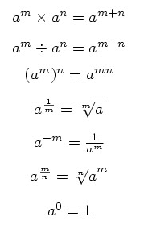

***Example 1*** (a) ** (b)  (c) ** 0 = 1

***Example 2*** 48 = 16  3 = 43

***Example 3*** 

### Exercise 1.6

**1** Write the following as powers of *x*.

(a) 

(b) 

**2** Write the following in the form *axn*.

(a) 

(b) 

**4** Write as sums of powers of *x*.



**5** Simplify the following surds.

(a) 

(b) 

(c) 

**6** Rationalise the denominators in the following expressions.

(a) 

(b) 

**7\*** Simplify .

*Note: This is quite a challenging question.*

# 2 Trigonometry

### 2.1 Trigonometric Equations

You can of course get one solution to an equation such as sin *x* = –0.5 from your calculator. But what about others?

***Example*** Solve the equation sin *x* = –0.5 for 0  *x* < 360.

***Solution*** The calculator gives sin–1(0.5) = –30.

This is usually called the *principal value* of the function sin–1.

To get a second solution you can either use a graph or a standard rule.

***Method 1:*** Use the graph of *y* = sin *x*

By drawing the line *y* = -0.5 on the same set of axes as the graph of the sine curve, points of intersection can be identified in the range

0  *x* < 360.

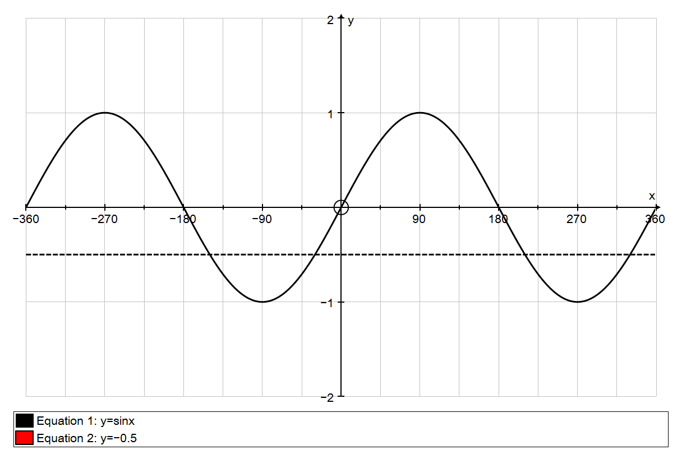

*x* = 210

*x* = 330

*x* = –30

*y* = sin *x*

*y* = –0.5

(The arrows each indicate 30 to one side or the other.)

Hence the required solutions are 210 or 330.

***Method 2:*** Use an algebraic rule.

To find the second solution you use sin (180 – *x*) = sin *x*

tan (180 + *x*) = tan *x*

cos (360 – *x*) = cos *x*.

Any further solutions are obtained by adding or subtracting 360 from the principal value or the second solution.

In this example the principal solution is –30.

Therefore, as this equation involves sine, the second solution is:

180 – (–30) = 210

–30 is not in the required range, so add 360 to get:

360 + (–30) = 330.

Hence the required solutions are 210 or 330.

You should decide which method you prefer.

The corresponding graphs for cos *x* and tan *x* are shown below.

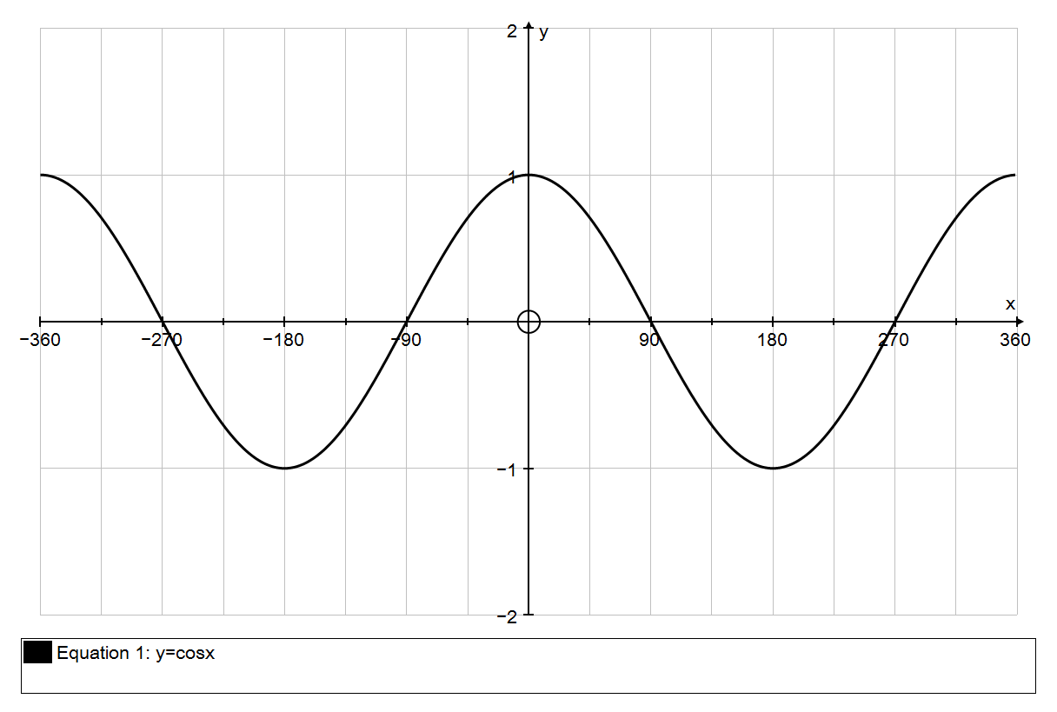

*y* = cos *x*

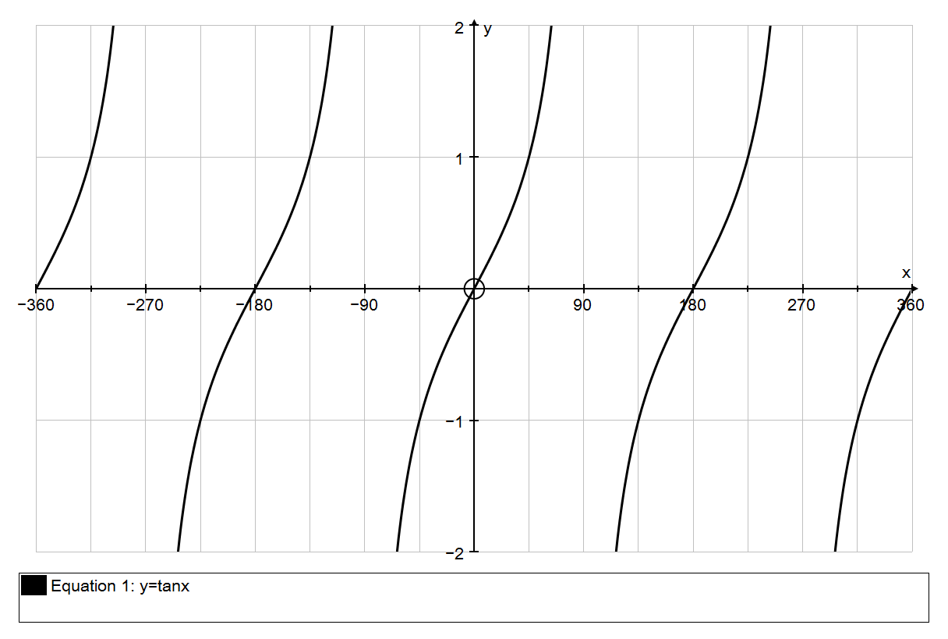

*y* = tan *x*

To solve equations of the form *y* = sin (*kx*), you will expect to get 2*k* solutions in any interval of 360. You can think of compressing the graphs, or of using a wider initial range.

### Exercise 2.1

**1** Solve the following equation for 0  *x* < 360. Give your answers to the nearest 0.1.

sin *x*= 0.9

**2** Solve the following equation for –180  *x* < 180. Give your answers to the nearest 0.1.

cos *x*= 0.6

**3\*** Solve the following equation for 0  *x* < 360. Give your answers to the nearest 0.1.

tan 4*x* = 2.05 *Note: This is quite a challenging question.*

### 

### 2.2 Other Trigonometric Methods

Suppose that you are told that sin *x* is exactly . Assuming that *x* is between 0 and 90, you can find the exact values of cos *x* and tan *x* by drawing a right-angled triangle in which the opposite side and the hypotenuse are 2 and 3 respectively:

*x*

3

2

Now Pythagoras’s Theorem tells you that the third, adjacent, side is .

Hence cos *x* =  and tan *x* = .

### Exercise 2.2

**Do not use a calculator in this exercise.**

**1** In this question ** is in the range 0  ** < 90.

(a) Given that , find the exact values of cos ** and tan **.

(b) Given that , find the exact values of sin ** and cos **.

(c) Given that , find the exact values of sin ** and tan **.

# 3 Graphs

No doubt you will have *plotted* many graphs of functions such as *y* = *x*2 – 3*x* + 4 by working out the coordinates of points and plotting them on graph paper. But it is actually much more useful for A Level mathematics (and beyond) to be able to *sketch* the graph of a function. It might sound less challenging to be asked to draw a rough sketch than to plot an accurate graph, but in fact the opposite is true. The point is that in order to draw a quick sketch you have to understand the basic shape and some simple features of the graph, whereas to plot a graph you need very little understanding. Many professional mathematicians do much of their basic thinking in terms of shapes of graphs, and you will be more in control of your work, and understand it better, if you can do this too.

When you sketch a graph you are *not* looking for exact coordinates or scales. You are simply conveying the essential features:

* the basic shape
* where the graph hits the axes
* what happens towards the edges of your graph

### Exercise 3.1

**1** Rearrange the following in the form *y* = *mx* + *c*. Hence find the gradient and the *y*-intercept of each line.

(a) 2*x* + *y* = 8

(b) 7*x* – 4*y* + 18 = 0

**2** Sketch the following lines. Show on your sketches the coordinates of the intercepts of each line with the *x*-axis and with the *y*-axis.

(a) 2*x* + 3*y* = 12

(b) 4*x* + 5*y* + 20 = 0

### 3.2 Basic shapes of curved graphs

You need to know the names of standard types of expressions, and the graphs associated with them.

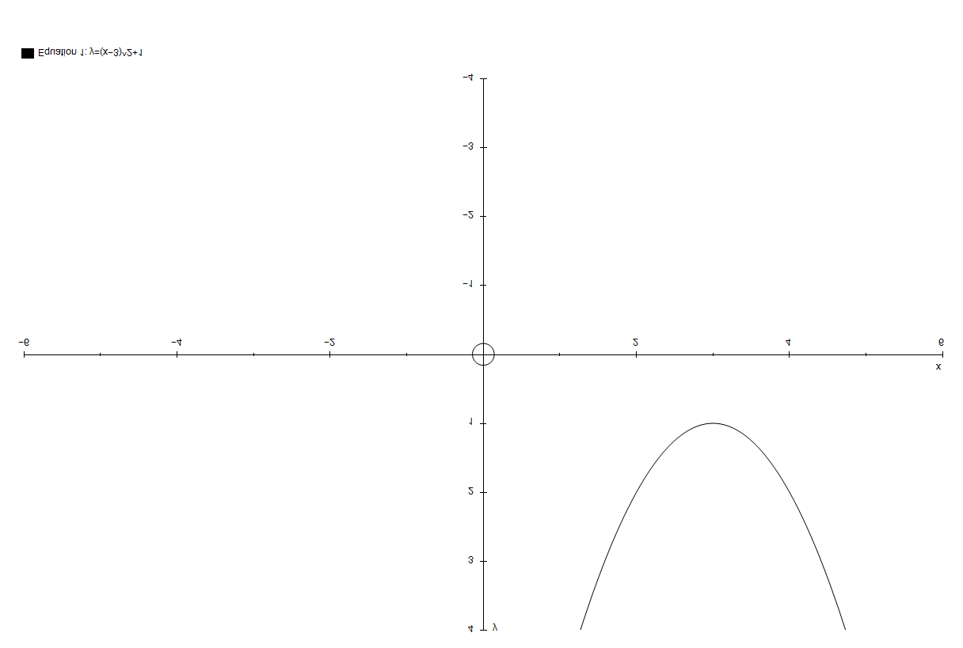 The graph of a **quadratic** function is a ***parabola:***

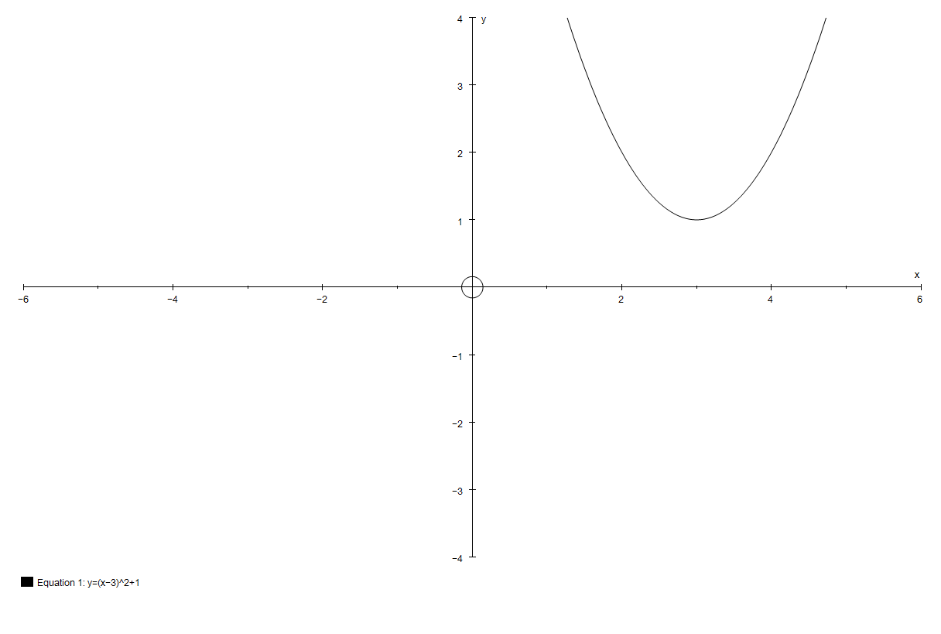

The graph of a **cubic** function

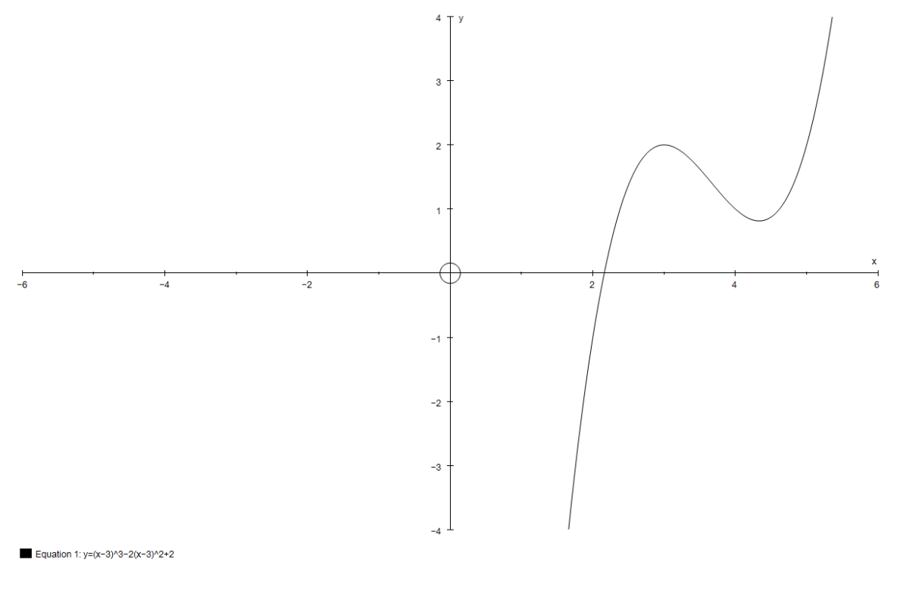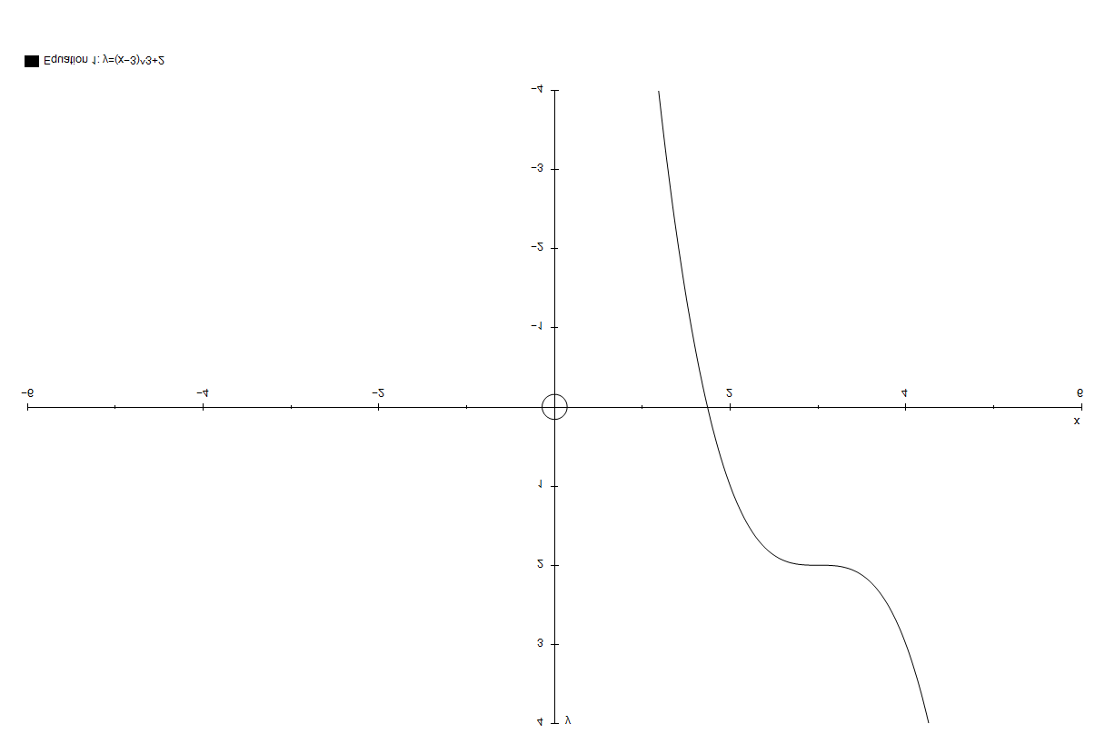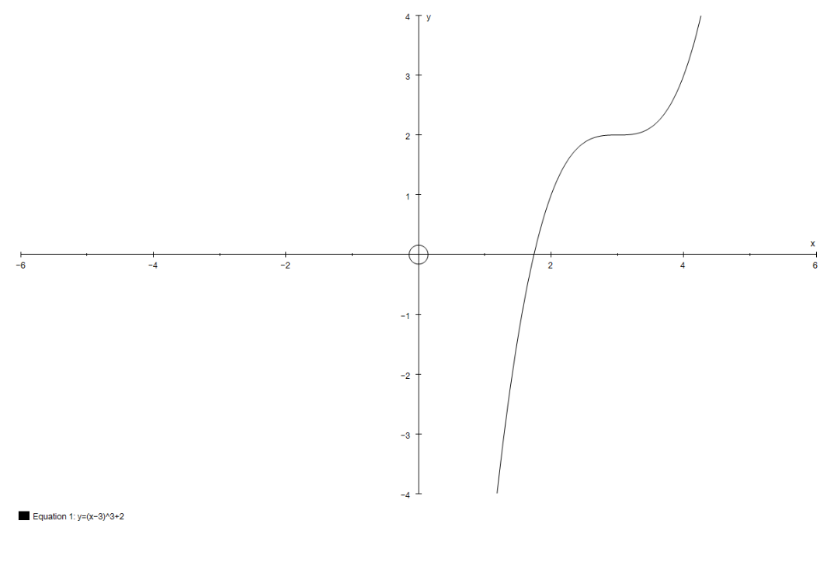

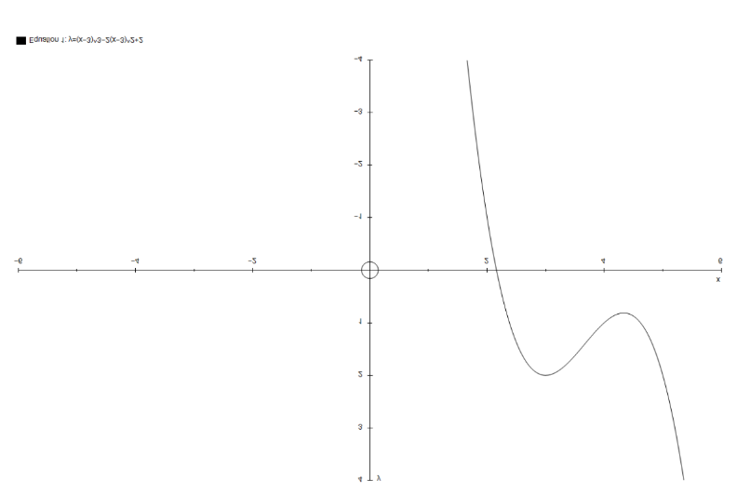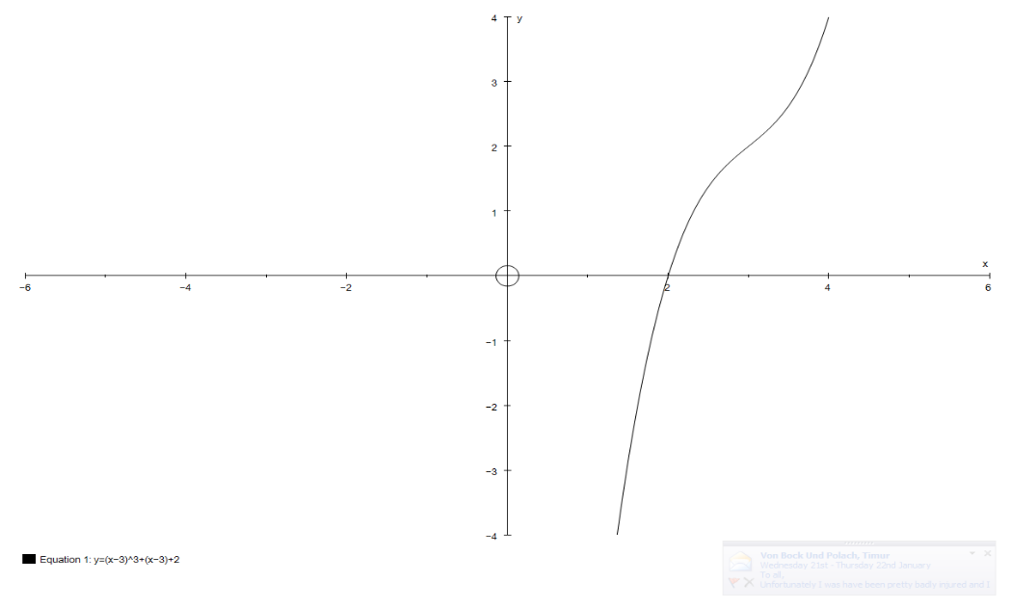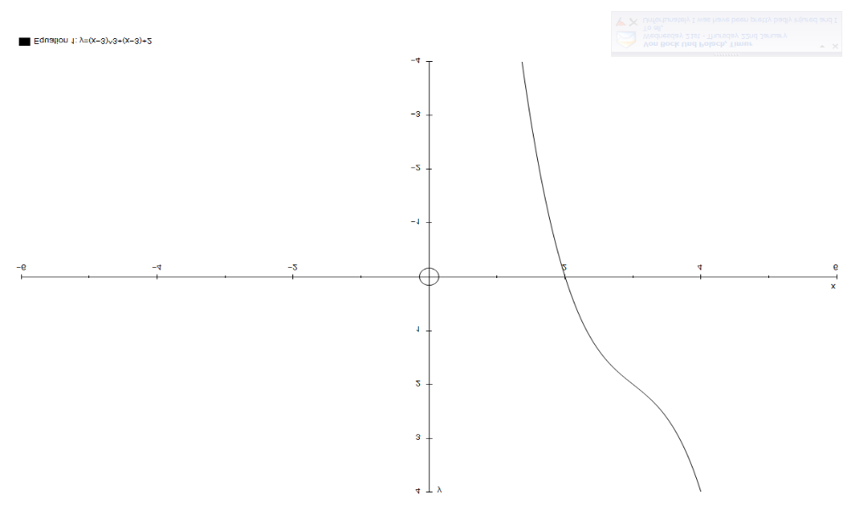

The graph of a **reciprocal**/***hyperbola***:

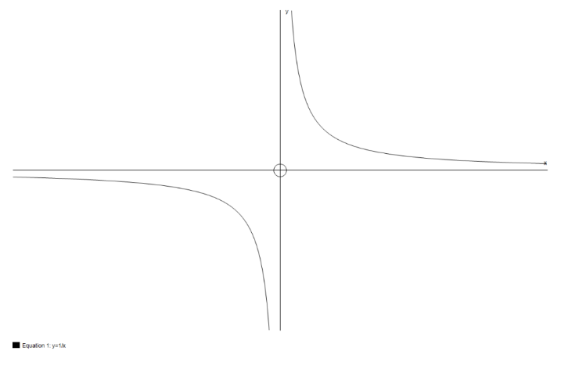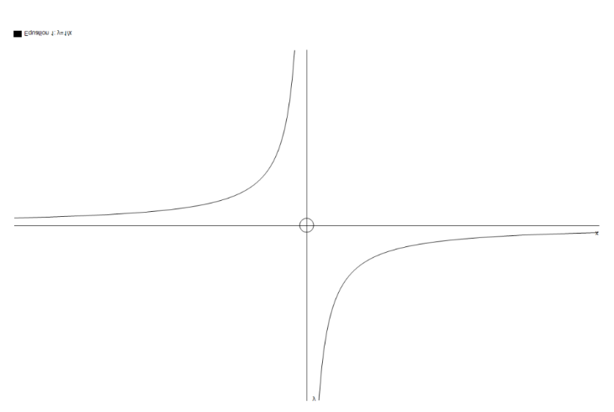

### Exercise 3.2

Sketch the curves using a different diagram for each.   
Show the coordinates of the intersections with the axes.

**1** *y* = (*x* + 2)(*x* – 4)

**2** *y* = *x*

**3** 

**4** 

**5** *y* = *x*3 – 4*x*

**6** *y* = 4 – *x*2