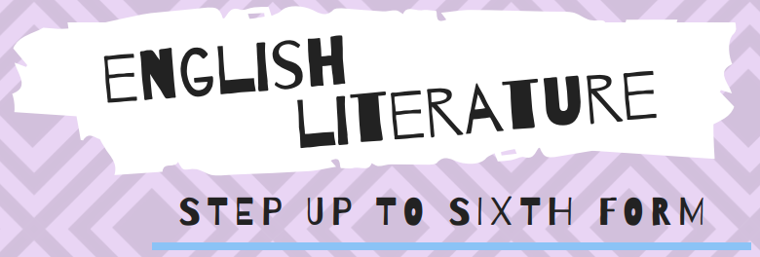

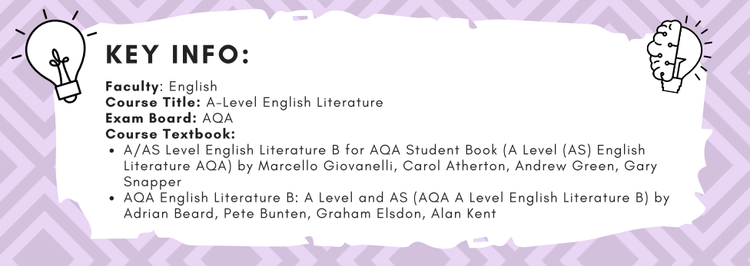

Transition Tasks to be handed in at the start of Year 12:

Task One
Prepare a three slide PowerPoint presentation titled:
‘Books that are Important to Me.’
This is not for formal assessing, but is to give your class teacher an idea of where your interests lie
Include:
● A minimum of two texts you have read and enjoyed
● Brief outline of the text
● Your personal response to it
There is no word count, it is up to you what you choose to say about each text.
Please be prepared to share some of your thoughts with class at the start of term.

Task Two
Othello – William Shakespeare
In this extract from early in the play, Iago and Roderigo, wake up Brabantio to tell him his daughter is
sleeping with Othello.
Answer the following question:
In this extract, what does the writer reveal about the characters of:
● Iago
● Othello
In this extract, how does the writer reveal this?

BRABANTIO
What is the matter there?
RODERIGO Signior, is all your family within?
IAGO Are your doors lock'd?
BRABANTIO Why, wherefore ask you this?
IAGO 'Zounds, sir, you're robb'd; for shame, put on
your gown;
Your heart is burst, you have lost half your soul;
Even now, now, very now, an old black ram
Is topping your white ewe. Arise, arise;
Awake the snorting citizens with the bell,
Or else the devil will make a grandsire of you:
Arise, I say.
BRABANTIO What, have you lost your wits?
RODERIGO Most reverend signior, do you know my voice?
BRABANTIO Not I; what are you? 90
RODERIGO My name is Roderigo.
BRABANTIO The worser welcome:
I have charged thee not to haunt about my doors:
In honest plainness thou hast heard me say
My daughter is not for thee; and now, in madness,
Being full of supper and distempering draughts,
Upon malicious bravery, dost thou come
To start my quiet.
RODERIGO Sir, sir, sir,--
BRABANTIO But thou must needs be sure
My spirit and my place have in them power
To make this bitter to thee.
RODERIGO Patience, good sir. 100
BRABANTIO What tell'st thou me of robbing? this is Venice;
My house is not a grange.
RODERIGO Most grave Brabantio,
In simple and pure soul I come to you.
IAGO 'Zounds, sir, you are one of those that will not
serve God, if the devil bid you. Because we come to
do you service and you think we are ruffians, you'll
have your daughter covered with a Barbary horse;
you'll have your nephews neigh to you; you'll have
coursers for cousins and gennets for germans.
BRABANTIO What profane wretch art thou?
IAGO I am one, sir, that comes to tell you your daughter
and the Moor are now making the beast with two backs.
BRABANTIO Thou art a villain.
IAGO You are--a senator.
BRABANTIO This thou shalt answer; I know thee, Roderigo.

Task Three
Go to these links on the AQA exam board site and read them. They are overviews of the genres that
are covered in each A Level paper:
1 Paper One - Aspects of Tragedy:
https://www.aqa.org.uk/subjects/english/as-and-a-level/english-literature-b-7716-7717/subject-con
tent-a-level/literary-genres
2 Paper Two - Elements of crime writing
https://www.aqa.org.uk/subjects/english/as-and-a-level/english-literature-b-7716-7717/subject-con
tent-a-level/texts-and-genres
After you have read these notes, make two mind maps outlining the key features of:
● The Tragic Genre
● The Crime Genre

CRITICAL VOCABULARY
Abstract Something that exists in thought or theory, rather than in concrete reality
Aesthetic Philosophy of beauty, a formal term for beauty – aesthetically pleasing
Affected Pretentious or artificial
Allegory A story with a secondary, moral meaning as well as its surface story
Alliteration Repetition of initial consonant sounds
Anagnorisis Moment where a character realises the truth about another character or themselves
- when Othello realises that Iago has deceived him, important as it is a dramatic moment that usually
highlights regret and deception
Antagonist The adversary or enemy
Aristotle Greek philosopher whose theories of tragedy are still referred to. He said tragedies
should include: 1) A flaw or error of judgment (hamartia) 2) A reversal of fortune (peripeteia)
brought about because of the hero's error in judgment. 3) The discovery or recognition that the
reversal was brought about by the hero's own actions (anagnorisis) 4) Excessive Pride (hubris) 5) The
character's fate must be greater than deserved.
Assonance Repetition of a vowel sound
Ballad Narrative poems that tell a clear story, like Keats’ La Belle Dame . . .
Baroque Something that is highly ornate and extravagant in style; originally from 17th and 18th
century Italian and German architecture
Bathos A sudden descent from the serious to the ludicrous
Bildungsroman A literary genre that focuses on the psychological and moral growth of the
protagonist from youth to adulthood, in which character change is important - seen
in The Kite Runner
Blank verse Poetry which does not rhyme.
Catharsis A moment, often in the final part of a tragedy, when the hero is cleansed of emotion
as a result of his experiences
Cliché Very commonly used phrase or opinion, which has lost its originality
Conceit An elaborate, surprising contrast between two dissimilar things
Couplet A two line section of a poem, which rhymes
Caesura The main pause in a line of verse
Cadence A fall in the pitch of the voice, a tonal inflection
Denouement The final resolution of a play or novel; in which all plots are unravelled
Diction A poet’s choice and arrangement of words
Didactic A work of art intended to teach; something with a clear lesson or moral
Dramatic Irony When the audience know more about events and characters than the characters
themselves do
Dramatic Monologue First person speaker articulates their thoughts, usually in narrative poems,
which tell a story
Dystopia Nightmarish vision of future - see The Handmaid’s Tale
Effect The result or consequence of something, the effect of words / images.
Elegy A poem of lament or mourning
End Stopping A verse line with a pause or stop at the end of it
Enjambment When one verse line runs into the next without a formal pause
Epic A long narrative poem
Epigraphs three quotations at the start of a text - see The Handmaid’s Tale
Epigram A brief, pointed and often witty saying
Euphemism Expressing something unpleasant in much milder language
Exposition The opening of a narrative that establishes setting, character and some plot
Fable A short tale or story conveying a clear moral lesson
Falling action The inevitable events that cannot be stopped, after the climax of the story - the
things that you know will happen and nothing can stop
Fictive autobiography text presented as an autobiography, but an invented life story - The
Handmaid’s Tale
Figurative Non-literal language, which represents something beyond itself
First-person Passages written from the ‘I’ point of view
Feminist Criticism Literary theory that explores the male bias of much literature, and examines
closely the portrayal of women
Foreshadowing A literary device in which a writer gives an advance hint of what is to come later in
the story
Fragmented, discontinuous narrative When a narrative does not go chronologically, instead it
zig-zags from the present to past and back again, creating an unsettling effect
Gothic Novel Popular novel in the 18 and 19th centuries, concerned with violence, passion and
supernatural events
Hamartia The fatal flaw of a character
Hubris Arrogant pride which lets tragic heroes to ignore warnings from the Gods
Hyperbole A deliberate exaggeration or overstatement
Interior Monologue A passage written from the first person, which is only going on in the speaker’s
head (novel’s version of drama’s soliloquy)
Imagery In its most basic form, figurative language, which enables you to picture the
described scene
Irony Saying one thing while meaning another
Lyric Firstly, a song played on an early stringed instrument, the lyre, but now a song-like
poem, dealing with thoughts and feelings, and is not narrative
Machiavellian figure a plotting, deceiving and dangerous character who has ill intent - they
want to cause trouble - like Iago in Othello
Metaphor A comparison between two objects, which states that one thing is not like
something else, but actually is something else
Metre The regular and repetitive use of stressed and unstressed syllables in poetry
Omniscient All knowing
Omnipresent Present everywhere
Onomatopoeia When the sound of the word resembles the thing being described – hiss, gargled,
buzz, plop . . .
Oxymoron A figure of speech in which two contradictory words are put together – dead lively,
open secret
Pastoral Literature that is concerned with country life
Pathetic Fallacy When a writer represents characters’ moods through their description of the natural
world about them
Pathos Moments in literature, which evoke strong feelings of sadness and pity
Peripeteia A sudden reversal of fortune
Personify Represent an abstract object as a person ‘Death walked in the door.’
Picaresque A novel in which the hero takes a journey.
Political and social protest writing Texts that focus on issues of power and powerlessness at their
core, with political and social protest issues central
Protagonist Leading character in literary text
Rising action The complications that create interest in a play - Iago’s trickery and deception
Rhythm The flow of words which, in poetry, can be measured in feet and metre.
Satire The use of ridicule, irony or even sarcasm in speech or writing to expose vice or folly.
Semantic field Group of related and linked words - key for imagery
Semantics A branch of linguistics concerned with the meaning of language
Sibilance In sibilance, hissing sounds are created. These soft consonants are s, with sh, ch, and
th. See Keats’ Lamia where the sibilance reinforces Lamias ‘serpent’ form
Simile A comparison of one thing with another, using the words, ‘as’ and ‘like’
Soliloquy A stage speech made by a character speaking his thoughts alone
Sonnet A poem of 14 lines with a fixed rhyme scheme.
Stream of consciousness The attempt in a novel to recreate the actual flow, pattern and
sense of thoughts as they pass through someone’s mind – an extended interior
monologue
Subjective A personal, individual outlook on something, distinct from an objective view
Sub-plot A secondary plot in a book or a play, which may provide comic relief from the main
events, or a different way of looking at things
Symbol A concrete expression of an abstract idea – the Cross is a symbol of Christianity.
Synaesthesia A way to present ideas, characters, or places so they appeal to more than one sense,
like hearing, sight, smell, and touch at a given time think of the transformation in Keats’ Lamia -
Theme The central idea, or ideas, examined by a book
Third-person Passages which are written from the ‘he’ or ‘she’ point of view
Tragedy Tragedy is a form of drama based on human suffering that invokes catharsis in
audiences, who regret the final outcome. The protagonist must die at the end as a result of earlier
hamartia, peripeteia, hubris and anagnorisis and the audience see the doomed protagonist suffer
greatly, largely as a result of their tragic flaw.
Tragic flaw The defect of a character that leads to the destruction of the protagonist in a tragedy
Tragic hero A literary character who makes a judgment error that inevitably leads to his/her own destruction.
Tone The mood of the poem – serious, regretful, comic . . .
Writer’s intention What the writer wanted to achieve by writing a piece – to pass on a message? a philosophical observation? to describe a person or place? to evoke anemotion or feeling?

