Criminology
Year 11 into Year 12 Summer Work

This work contains task to complete over the summer which will help prepare you for your A-Level studies in our Sixth Form.

Task 1
Task 2
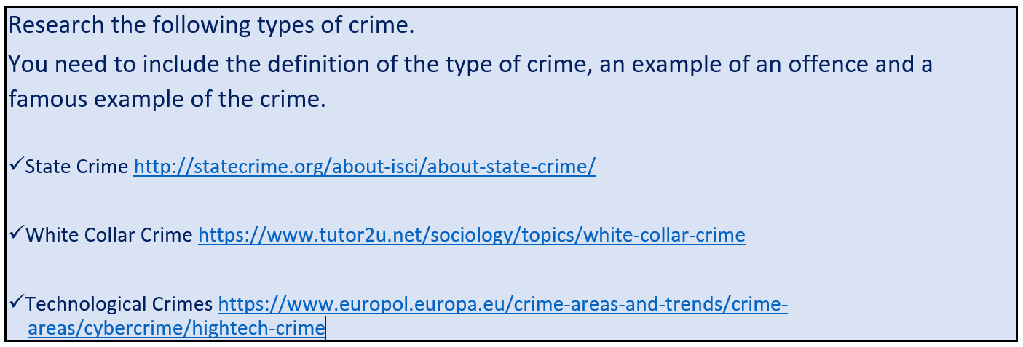

Task 3
