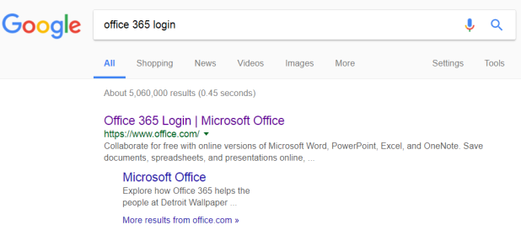
Office 365: Student/Teacher Communication Platform
Login instructions:
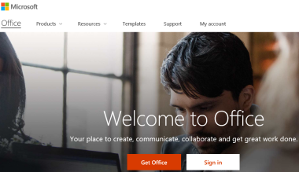
Step 1 –search for “Office 365 Login” in Google and click on

Step 2 – Click “Sign in”

Step 3 – The login page may look different to the one in the picture. Username:
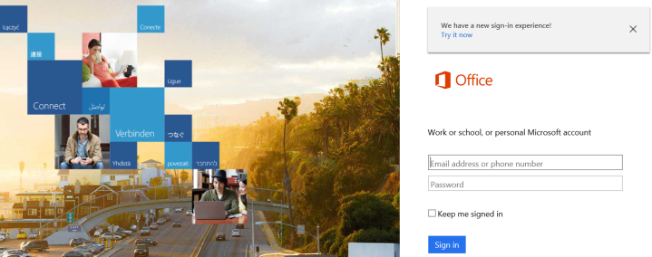
If Year 7 then the first 2 numbers are 19
If Year 8 then the first 2 numbers are 18
If Year 9 then the first 2 numbers are 17
If Year 10 then the first 2 numbers are 16
If Year 11 then the first 2 numbers are 15
If Year 12 then the first 2 numbers are 14
If Year 13 then the first 2 numbers are 13
Followed by first 4 letters of their surname and then the first initial of their first name.
So if your child’s name is Bob Child and is in year 9, their username is: 17chilb@anthonygell.co.uk
Their password is the same password they would use to logon to a school computer.

Step 4 – The Office 365 Homepage is then displayed as shown below:
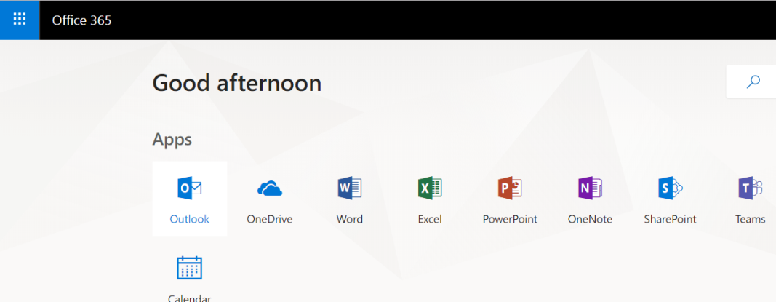
Step 5 – Click here to open emails
Step 6 – to send an email, click new message
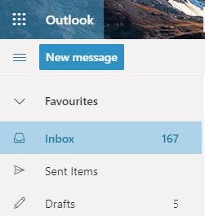

Step 7 - if you wanted to send an email to Miss Roberts then type the teachers surname into the “To” field and it will show names of different people in the school with that surname (shown below):
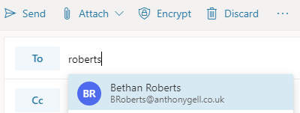

Other features of Office 365
OneDrive – Your child can store up to 5TB of work into this cloud based storage area (similar to Dropbox).
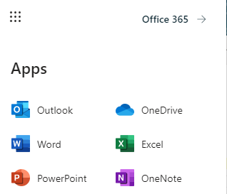
Free versions of Word, PowerPoint & Excel are built in.

Hints and tips –
When you open a product e.g. PowerPoint the document automatically saves into OneDrive (no need to click save).
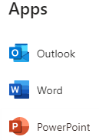
Example: if your child is asked to produce a PowerPoint on French Towns:
Step 1: Click on PowerPoint
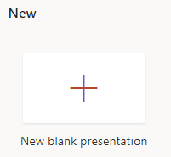
Step 2: Click here

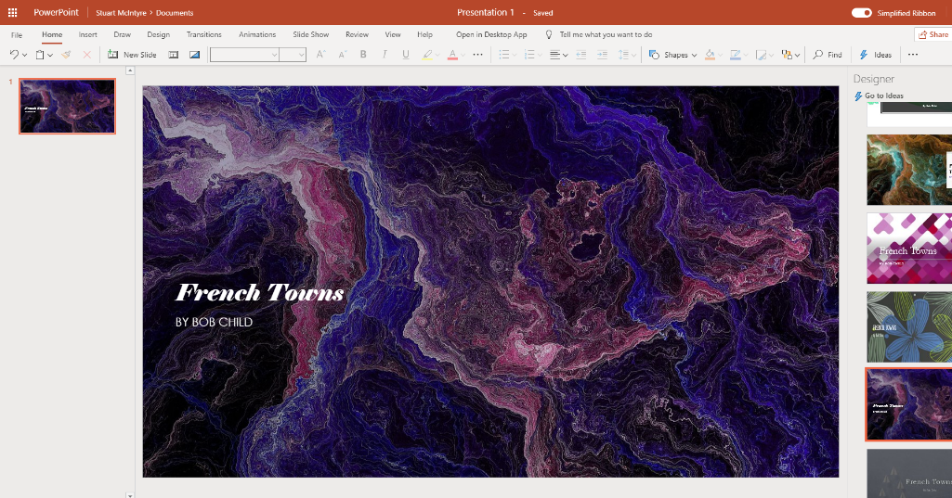
Step 3: Add the title & choose a design from the right hand side menu

Step 4: This PowerPoint saves into your OneDrive automatically
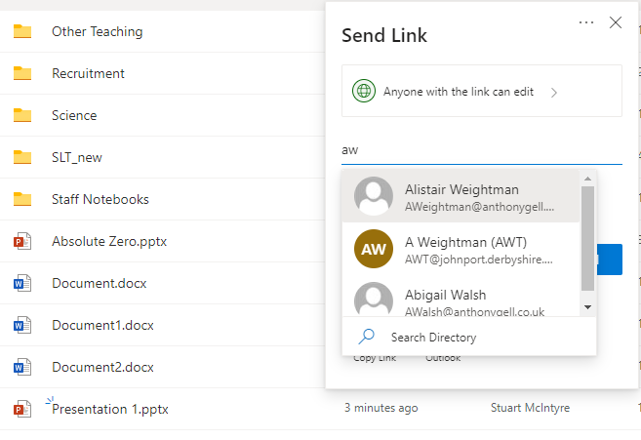

Step 5: to send this to your French
Teacher (Miss Walsh), click on the “share”
Icon next to the file name and the
“Send Link” box pops up. Type the surname
of the teacher, select the teachers name and
then click “Send”.

